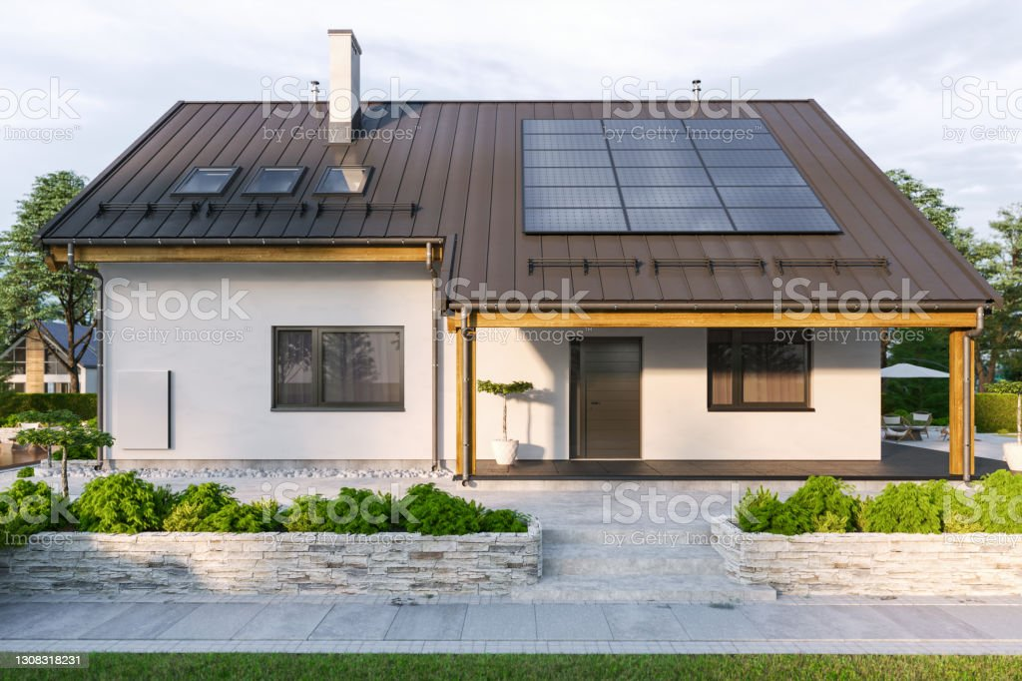

**SUSTAINABLE ENERGY EFFICIENT HOUSE**

**PROJECT**

There were two components to this assignment. A ‘write-up’ report (1-2 pages in length), and a three-dimensional model house.

1. The reporting component requires a detailed summary of how the students chose to incorporate the use of sustainable energy efficient design. We needed to include an example of how each energy saving feature utilised a method of heat transfer to either reduce or enhance heating and/or cooling in our house. Each student was required to research, investigate, and include features for convection, conduction, and radiation.

* Convection describes the movement of particles due to differences in temperature. A transfer of heat energy occurs as particles are heated, they become less dense and rise. The colder, denser air falls – creating a circular movement of air known as a convection current. Some examples in our houses include strategic window placement, whirly birds and insulation in the ceiling.
* Conduction describes the transfer of heat through the vibration of particles. As particles collide with one another, heat energy is transferred from one particle to the next.  Examples include double glazing of windows, cavity walls, insulation, and curtains.
* Radiation describes the transfer of heat energy through light. All objects radiate heat if they are at a temperature that is higher than their surroundings. Examples include the orientation of the house, deciduous tree placement, and the use of structures such as pergolas to provide protection from the sun.
* The write-up could indicate whether or not under floor heating, position of the house for passive heating and cooling etc…
* Geographical positioning of the house – living areas facing a northerly direction

1. Use of sustainable reusable resources the last component of the assignment was the design and building process. A 3-dimensional model of our house – bringing it to life. This component involved working on their creativity, innovative design, and practical skills to construct the models out of various reusable materials to represent ‘real-life’ building materials.

* When designing the yard that the house is enclosed on, or underneath or part of (if built partially inside the side of a hill) -ensure the plants, ground coverings –grass lawn, mulch , pavements etc., water tower, windmill, fence design – for passive heating and cooling of the house. Use of recycled materials to build a sustainable energy efficient house. For example, pebbles to represent stone, cardboard and paper –brick or stone designed, bits of wool for wool insulation, al foil for insulation, painted/ coloured –in paper top represent types of floor covering or use of cutup bits of old carpet etc., left over material for pelmets, curtains etc.
* Interior of house -1 x room only

Through this assignment, the Year 8s have had first-hand experience of the integration of Science, Technology, Engineering, Arts and Mathematics (STEAM). They’ve applied their knowledge of the Physics of energy (heat) transfer to the real world (sustainable energy efficient housing).